How to run the Agrodem plugin

Before opening the plugin make sure that the necessary files are loaded into your current QGIS session. You will need four datasets for the plugin to function correctly:

1. **Administrative boundaries**
2. **Elevation map**
3. **River network**
4. **Reservoirs (or other source of surface water)**

In order to use the plugin:

1. Open the plugin from the **Plugin** menu. The name of the plugin when installed will be Agrodem
2. The following window will open up:

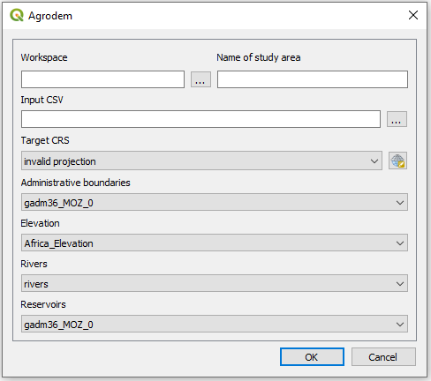

Figure . Plugin GUI

1. In the field named **Workspace**, click on the three dots on the right hand side of the field and navigate to an empty folder.

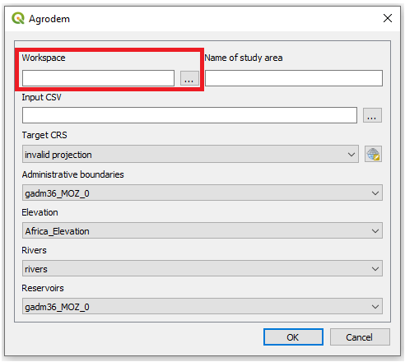

Figure . Select workspace.

1. Enter the name of the study area in the next box.

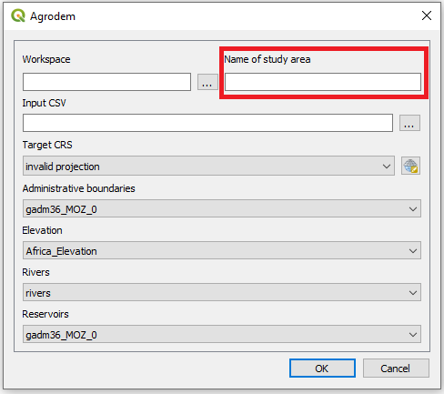

Figure 3. Enter the name of the study area

1. Select the CSV file that you want to use as your base. This csv file has to include the following columns:

* **pixel** - Unique id for each pixel of the agricultural area
* **State** - Name of the dissagregated states
* **lon** - Longitude (in EPSG:4326)
* **lat** - Latitude (in EPSG:4326)
* **Crop** - Crop in area
* **Fraction** - The Fraction that is cultivated
* **CropArea** - Area occupied by crop

**Note: Do not load the csv file into QGIS instead use the three dots next to the field.**

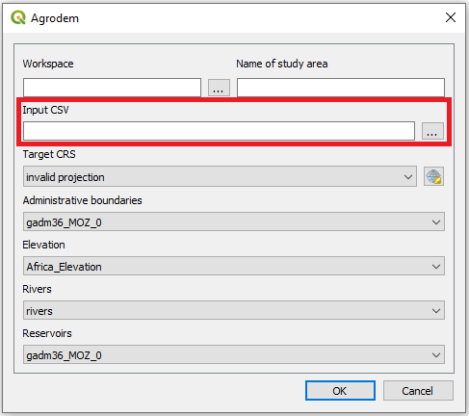

Figure . Select the input csv

1. Next chose the **projection system.** Make sure that the projection system is in a linear unit and that this linear unit is meters.

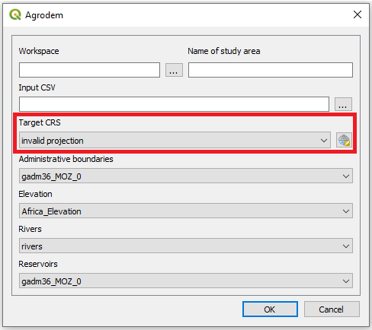

Figure 5. Select projection system

**NOTE: When selecting the projection system the following window will open up:**

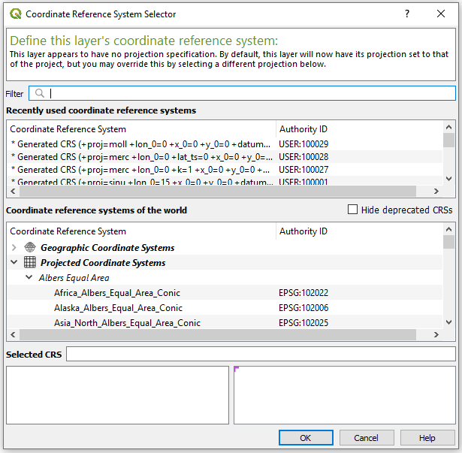

Figure 6. Projection selection window

**To find the coordinate system that is appropriate for your study area please visit** [**http://epsg.io/**](http://epsg.io/) **and search for your area of interest.**

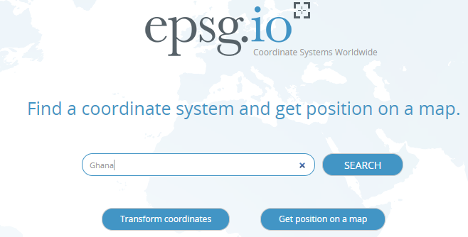

Figure 7. Go to epsg.io and search for the country you want to reproject

**This will present you with a list of coordinate systems suitable.**

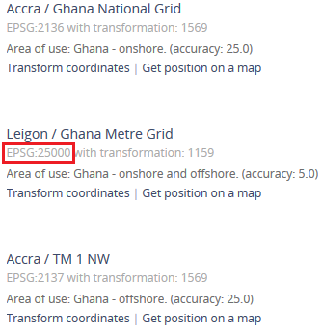

Figure 8. You will get a list of different coordunate systems that fit with your study area. Choose one and note its EPSG code.

**Next, come back to QGIS. Click on the icon next to the field and check the EPSG code received from the webpage. Choose one where the unit is in meters and the red box covers the whole area you are working with.**

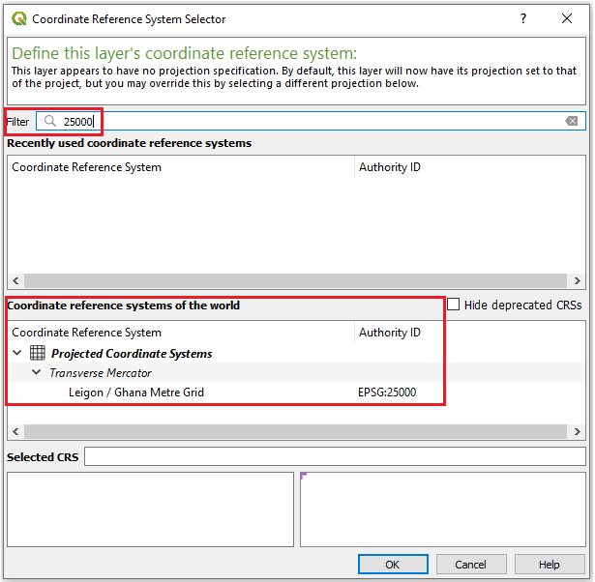

Figure 9. Enter the coordinate system you have chosen in the field. Make sure that the unit is meters (lower left box) and that the red area covers your study area (lower right box)

1. In the next four boxes select the appropriate datasets.

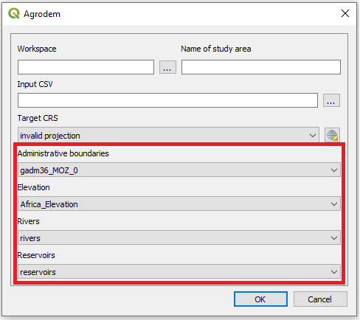

Figure 10. Enter the datasets used for the creation of the clusters

1. Plugin may take some time to run depending on the size of the study area. During this time QGIS can not be used. For the example case of Mozambique (~170,000 rows) the plugin takes approximately 10 minutes to run.